**Bryan Velez Moreno**

**Nmap Exercise**

* **Task 2 – Subnetworks**

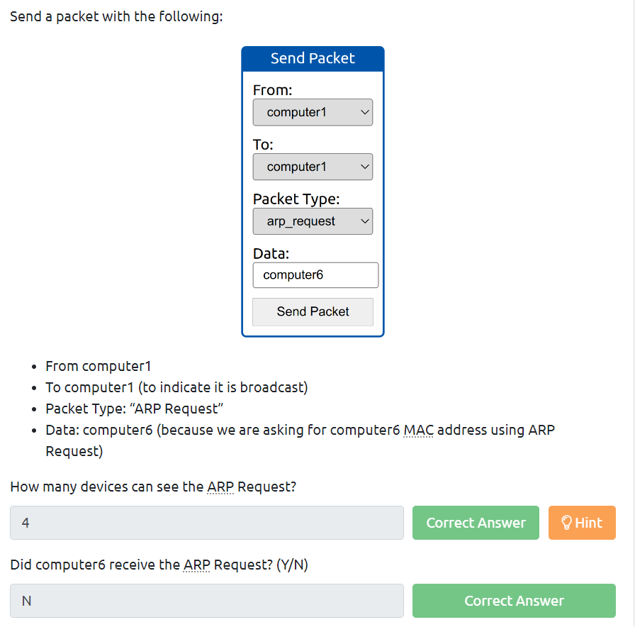

* **Task 3 – Enumerating Targets**

* **Task4 - Discovering Live Hosts**

* **Task5 – Nmap Host Discovery Using ARP**

* **Task6 - Nmap Host Discovery Using ICMP**

* **Task7 -  Nmap Host Discovery Using TCP and UDP**

* **Task8 - Using Reverse-DNS Lookup**

